Part 1

Before you start you need to run the script which will add to your project all necessary datasets.
- Login to GCP panel: https://console.cloud.google.com
- Check that you are in proper project:
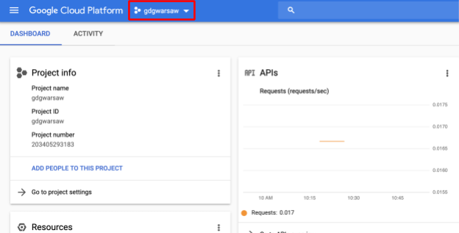
- Open Google Cloud Shell:
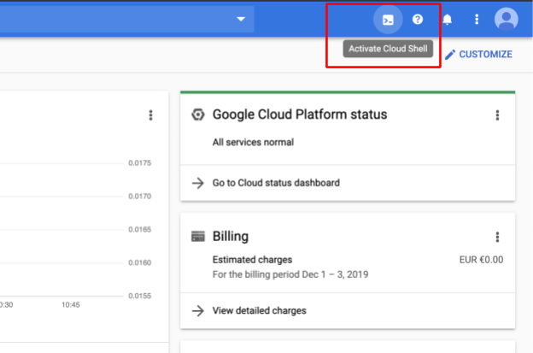
- Check credentials:

You can list the active account name with this command:
gcloud auth list
Example output:
Credentialed Accounts
ACTIVE ACCOUNT
* emil@appsdemo.se

You can list the project ID with this command:
gcloud config list project

Example output:
[core]
project = gdgwarsaw

Your active configuration is: [cloudshell-27209]

If you are not seeing information about project use command:

gcloud config set project PROJECT_ID

- Set the username and email address for your Git commits in this repository. Replace [USERNAME] with a username you create:
git config --global user.email "$(gcloud config get-value core/account)"

git config --global user.name "[USERNAME]"
Where [USERNAME] is your name.
- Clone data from Google Source Repository
git clone https://github.com/EmilAvalon/gdgwarsaw2019.git

- Go to folder
cd gdgwarsaw2019
- Change permissions to config script:

chmod +x gcp_config.sh

- Run script:

./gcp_config.sh

- Well done!!!

